# 实验二 线性表的链式存储系统维护

**一、实验目的**

1.掌握线性表的链式存储的定义和基本使用方法。

2.掌握线性表的链式存储存储单元的排列特点。

3.掌握线性表的链式存储系统的建立、遍历、插入、查找 、删除操作，学会相关的函数定义和调用。

**二、实验内容**

1.建立一个链表。

2.能够对建立的链表进行查找、修改、插入、删除等操作。当输入指令错误时，能够提示错误信息。主函数中可以选择由switch\case语句构成主菜单，再根据提示进行相应操作。

**三、实验指导**

1.以循环的方式建立一个有表头的链表；

2.遍历链表，并计算链表结点个数；

3.在查找功能中要实现：当能找到时打印该值的前驱结点，找不到时输出“没找到”；

4.在插入功能中要实现：在某个特定的结点之后插入一个结点；

5.在删除功能主要实现：删除特定值的结点，注意区分该节点是否为链表结尾。

**四、代码实现**

*//Experiment 2: Linked List by:Yang Yujie using C++*#include <iostream>  
using namespace std;  
  
typedef struct LNode{  
 int value; *//头结点L->value的值表示单链表中的元素个数；其他结点LNode->value的值表示单链表结点中存储的值。* struct LNode* next;  
}LNode, *LinkedList;  
  
bool InitializeList (LinkedList &L);*//初始化链表，以固定格式输入建立链表。*bool ShowLinkedList (LinkedList L);*//遍历链表并打印。*bool InsertElement (LinkedList &L, int InsertedElement, int GoalElem);*//插入操作。*bool LocateElement (LinkedList L, int GoalElem, int &Location);*//定位操作，通过引用返回目标元素的标号。*bool ModifyElement (LinkedList &L, int FormerElem, int NewElem);*//修改操作。*bool DeleteElement (LinkedList &L, int &Location, int ElementDelete);*//删除操作，通过引用返回被删除元素的标号。  
  
//元素的位置标号从1开始。*int main() {  
 int command;  
 LinkedList test;  
 cout << "Experiment 2: Linked List." << endl  
 << "<Instruction> Please initialize the linked list." << endl;  
 InitializeList(test);  
 ShowLinkedList(test);  
  
 cout << endl  
 << "<Instruction> Please type in the command number to operate:"  
 << endl << endl;  
 cout << "/* The command corresponds to operations.\n"  
 " * command -1:Terminate the program.\n"  
 " * command 1 :LocateElement.\n"  
 " * command 2 :ModifyElement.\n"  
 " * command 3 :InsertElement.\n"  
 " * command 4 :DeleteElement.\n"  
 " */" << endl;  
  
 while (cin >> command) {  
 switch (command) {  
 case 1: {  
 int GoalElem, Location;  
 bool flag1 = true;  
 while (flag1) {  
 cout << "/* LocateElement */" << endl;  
 ShowLinkedList(test);  
 cout << "\n<Instruction> Please type in the located element:";  
 cin >> GoalElem;  
 if (LocateElement(test, GoalElem, Location)) {  
 flag1 = false;  
 } else {  
 flag1 = true;  
 }  
 }  
 } break;  
  
 case 2: {  
 int FormerElem, NewElem;  
 bool flag2 = true;  
 while (flag2) {  
 cout << "/* ModifyElement */" << endl;  
 ShowLinkedList(test);  
 cout << "\n<Instruction> Please type in the former element:";  
 cin >> FormerElem;  
 cout << "<Instruction> Please type in the new element:";  
 cin >> NewElem;  
 if (ModifyElement(test, FormerElem, NewElem)) {  
 ShowLinkedList(test);  
 flag2 = false;  
 } else {  
 flag2 = true;  
 }  
 }  
 } break;  
  
 case 3: {  
 int InsertedElement, GoalElem;  
 bool flag3 = true;  
 while (flag3) {  
 cout << "/* InsertElement */" << endl;  
 ShowLinkedList(test);  
 cout << "\n<Instruction> Please type in the inserted element:";  
 cin >> InsertedElement;  
 cout << "<Instruction> Please type in the located element:";  
 cin >> GoalElem;  
 if (InsertElement(test, InsertedElement, GoalElem)) {  
 ShowLinkedList(test);  
 flag3 = false;  
 } else {  
 flag3 = true;  
 }  
 }  
 } break;  
  
 case 4: {  
 int LocationDelete = 1;  
 bool flag4 = true;  
 int ElementDelete;  
 while (flag4) {  
 cout << "/* DeleteElement */" << endl;  
 ShowLinkedList(test);  
 cout << "\n<Instruction> Please type in the Element to delete:";  
 cin >> ElementDelete;  
 if (DeleteElement(test, LocationDelete, ElementDelete)) {  
 ShowLinkedList(test);  
 flag4 = false;  
 } else {  
 flag4 = true;  
 }  
 }  
 } break;  
  
 case -1: {  
 cout << " <Instruction> The program terminated! " << endl;  
 } break;  
  
 default: {  
 cout << "The command is invalid!" << endl;  
 } break;  
  
 }  
 if (command == -1) {  
 break;  
 }  
 cout << endl  
 << "<Instruction> Please type in the command number to operate."  
 << endl << endl;  
 cout << "/* The command corresponds to operations.\n"  
 " * command -1:Terminate the program.\n"  
 " * command 1 :LocateElement.\n"  
 " * command 2 :ModifyElement.\n"  
 " * command 3 :InsertElement.\n"  
 " * command 4 :DeleteElement.\n"  
 " */" << endl;  
 }  
 return 0;  
}  
  
bool InitializeList (LinkedList &L) {  
 L = new LNode;  
 if(!L){  
 cout << "<InitializeList>\nThe Initialization goes WRONG!" << endl;  
 return false;  
 }else {  
 L->next = nullptr;  
 L->value = 0;  
 int tempch;  
 LNode* WorkPtr = L;  
 cout << "<InitializeList>\nThe input format: a1 a2 a3 ... an\\n" << endl;  
 while (true) {  
 LNode* NewNode = new LNode;  
 NewNode->next = nullptr;  
 WorkPtr->next = NewNode;  
 cin >> NewNode->value;  
 L->value++;  
 WorkPtr = WorkPtr->next;  
 tempch = getchar();  
 if (tempch == '\n') {  
 break;  
 }  
 }  
 cout << "\n<InitializeList>\nThe LinkedList has been initialized!" << endl;  
 return true;  
 }  
}  
  
bool ShowLinkedList (LinkedList L) {  
 if(L == nullptr) {  
 return false;  
 }  
 LNode* WorkPtr = L->next;  
 cout << "<ShowLinkedList>\n";  
 cout << "*** Numbers of elements: " << L->value << endl;  
 cout << "*** LinkedList: " << endl;  
 while (WorkPtr) {  
 cout << WorkPtr->value;  
 if (WorkPtr->next) {  
 cout << " -> ";  
 }  
 WorkPtr = WorkPtr->next;  
 }  
 cout << '\n';  
 return true;  
}  
  
bool InsertElement (LinkedList &L, int InsertedElement, int GoalElem) {  
 LNode* WorkPtr = L->next;  
 while ((WorkPtr) && (WorkPtr->value != GoalElem)) {  
 WorkPtr = WorkPtr->next;  
 }  
 if (!WorkPtr) {  
 cout << "<InsertElement>\nGoal Element Not Found." << endl;  
 return false;  
 }  
 LNode* NewNode = new LNode;  
 NewNode->value = InsertedElement;  
 NewNode->next = WorkPtr->next;  
 WorkPtr->next = NewNode;  
 L->value++;  
 cout << "<InsertElement>\nOperating Success!" << endl;  
 return true;  
}  
  
bool LocateElement (LinkedList L, int GoalElem, int &Location) {  
 LNode* WorkPtr = L->next, *FormerNode = L; int i = 1;  
 while ((WorkPtr) && (WorkPtr->value != GoalElem)) {  
 i++;  
 WorkPtr = WorkPtr->next;  
 FormerNode = FormerNode->next;  
 }  
 if (i > L->value) {  
 cout << "<LocateElement>\nGoal Element Not Found." << endl;  
 return false;  
 } else {  
 Location = i;  
 cout << "<LocateElement>\nOperating Success!" << endl;  
 cout << "*** GoalElem at the Location: "  
 << Location << endl;  
 cout << "*** Former Node: "  
 << FormerNode->value << endl;  
 return true;  
 }  
}  
  
bool ModifyElement (LinkedList &L, int FormerElem, int NewElem) {  
 LNode* WorkPtr = L->next;  
 while ((WorkPtr) && (WorkPtr->value != FormerElem)) {  
 WorkPtr = WorkPtr->next;  
 }  
 if (!WorkPtr) {  
 cout << "<ModifyElement>\nOperating Failed." << endl;  
 return false;  
 }  
 if (WorkPtr->value == FormerElem) {  
 WorkPtr->value = NewElem;  
 cout << "<ModifyElement>\nOperating Success!" << endl;  
 cout << "The Former Node <"  
 << FormerElem << "> has been modified to <"  
 << NewElem << ">." << endl;  
 return true;  
 }  
 return false;  
}  
  
bool DeleteElement (LinkedList &L, int &Location, int ElementDelete) {  
 LNode* WorkPtr = L->next, *FormerNode = L; Location = 1;  
 bool IsTailNode = false;  
 while ((WorkPtr) && (WorkPtr->value != ElementDelete)) {  
 WorkPtr = WorkPtr->next;  
 FormerNode = FormerNode->next;  
 Location++;  
 }  
 if (!WorkPtr) {  
 cout << "<DeleteElement>\nOperating Failed." << endl << endl;  
 return false;  
 }  
 if (WorkPtr->value == ElementDelete) {  
 if (!WorkPtr->next) {  
 IsTailNode = true;  
 }  
 LNode *DeletedNode = WorkPtr;  
 FormerNode->next = WorkPtr->next;  
 delete DeletedNode;  
 L->value--;  
 cout << "<DeleteElement>\nOperating Success!" << endl;  
 cout << "The node <"  
 << ElementDelete << "> at the location <"  
 << Location << "> has been deleted." << endl;  
 if (IsTailNode) {  
 cout << "The deleted node is at the tail." << endl;  
 } else {  
 cout << "The deleted node is not at the tail." << endl;  
 }  
 return true;  
 }  
 return false;  
}

**五、程序调试**

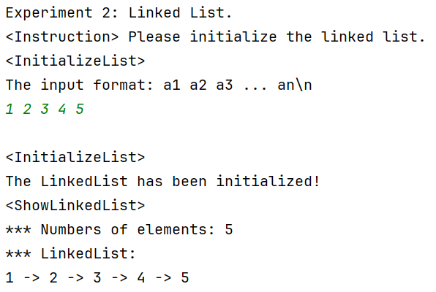

图 1 单链表初始化

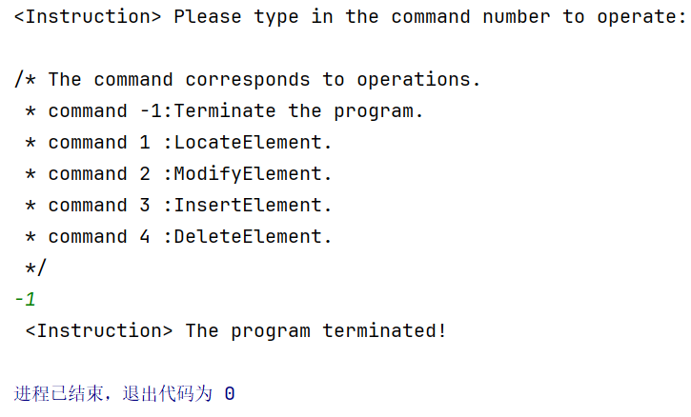

图 2 程序退出

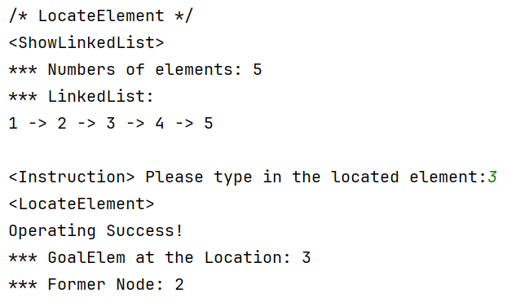

图 3 单链表查找成功

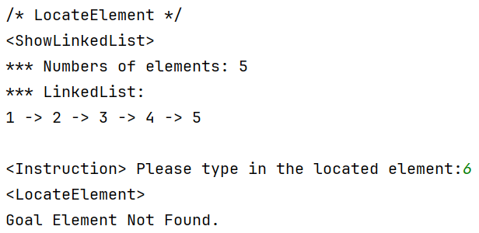

图 4 单链表查找失败

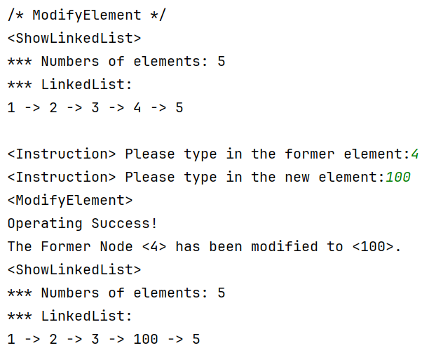

图 5 单链表修改成功

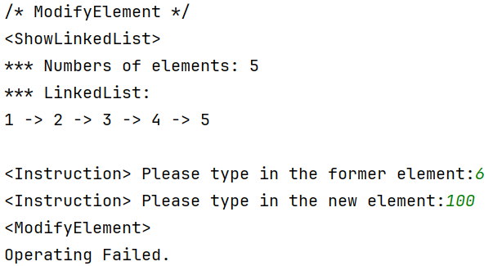

图 6 单链表修改失败

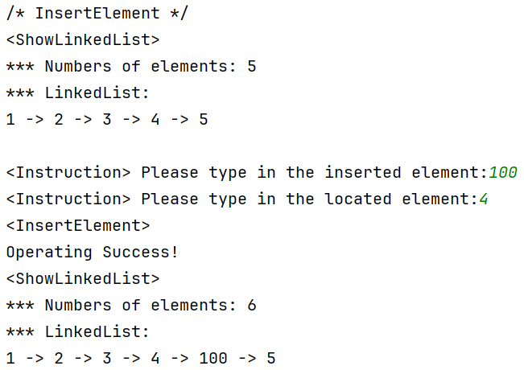

图 7 单链表插入成功

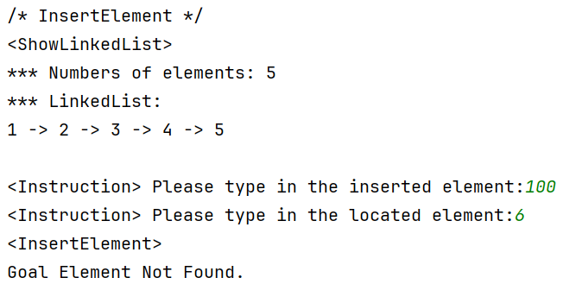

图 8 单链表插入失败

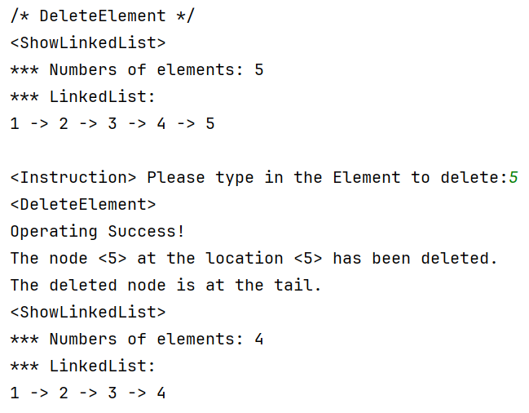

图 9 单链表删除成功（附带删除尾结点提示）

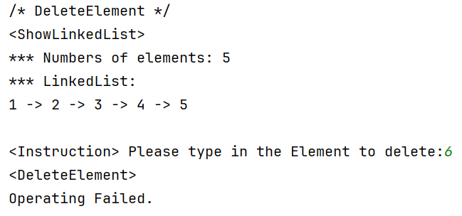

图 10 单链表删除失败